Name: Alexis N. Block: 3
The Synthesis and Detection of Copper

Purpose: The purpose of this lab is to see the chemical changes in copper chloride when it changes to pure copper. It is also to understand what compounds were broken apart and put back together in the process of the chemical changes.

Materials: Please refer to Science 9 textbook page 81. Instead of 25mL of hydrochloric acid, we used 20mL.

Procedures: Please refer to Science 9 textbook page 81. Step #9: We used a wooden splint instead of crucible tongs.

Observations:
- The copper (II) chloride solution is a bright blue and clear
- When we put the aluminium foil into the copper (II) chloride, the liquid started bubbling around it
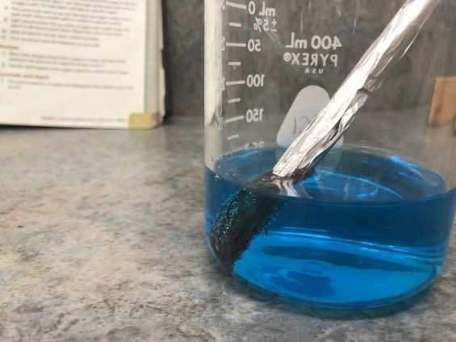
- There was red powder forming around the aluminium foil
- The foil started breaking down and falling apart
- The solution was exothermic
  - The beaker was warm and steaming up
- It smelled like a mix of swimming pool and cleaning detergent
- Once we submerged the whole roll of aluminium foil, it looked somewhat like it was rusting
- Bits of the powder sunk to the bottom
- After a while, the liquid went from a bright blue to a murky, darker blue
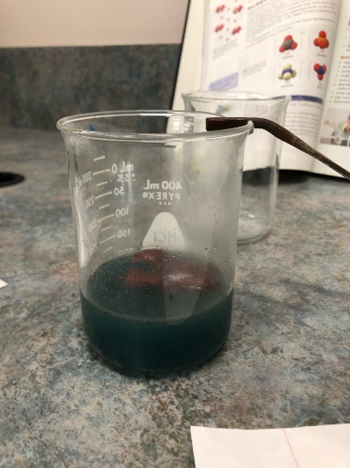
- All the powder settled at the bottom
- While washing the copper powder out with water, the water turned red but got clearer the more we rinsed it
- After the third rinse, the water turned orange and brown and not red
- The mix doesn’t give off heat anymore
- After rinsing the solution, the powder was a red and brown colour
- When we scooped up the copper onto a wooden splint and held it over the Bunsen burner, the flames got bigger and turned green
- The fire fumes smelled like a campfire
- After the end of the splint where the copper was burnt off, the flames went back to blue

Discussion Questions:
Analyze
- Colour changes that showed a chemical change took place when the aluminium was placed in the copper (II) chloride solution were the aluminium foil going from silver to red, the red powder forming, and the liquid turning from bright blue to more of a grey-blue.
- When the copper is over the Bunsen burner flame, the flames grow, and the flame turns from blue to green. When the copper was burning, it was a chemical change because it is not able to go back to the form it was in before burning it.
Conclude and Apply
- Properties that distinguish copper are that copper turns green when oxidized (when it’s rusting), copper is naturally brown, so it is easy to identify it compared to most other metals on the periodic table who are naturally silver or grey.

Conclusion:
In conclusion, the aluminium foil separated the pure copper from the chlorine. The chlorine created chlorine gases (hence why it smelled like cleaning solution), and the pure copper was left in the beaker. Most of the aluminium foil was broken down. This mixture was exothermic, as the inside of the beaker was steaming up, and the outside of the glass was warm. After the rinsing to purify the copper, when the copper was held over the flame, it turned the flame green and made the flame larger, as the wooden splint was also burning.
The reaction in the beaker was
2Al + 3CuCl₂ ----> 3Cu + 2AlCl₃
The aluminium foil got broken down by the chlorine, which also released chlorine gases into the air, therefore it made aluminium chloride. Since the chlorine was stripped from the copper, the copper is left in its pure form.
The second reaction is
2Cu + O₂ ----> CuO
The copper that burned turned the flame green because when copper is oxidized, it turns green. In fire, there’s oxygen, so when the copper burned, it oxidized. Because the copper is copper (II), the flame turned green. If it was copper (I), the flame would be blue. The flame made the copper go back to copper (II) because originally the copper had an ion charge of zero, but it lost electrons in the when it was burning to make it have a positive charge.

