GLENEAGLE SCHOOLWIDE CORE COMPETENCY ACTIVITY NOVEMBER 18, 2020
FOCUS: PERSONONAL AWARENESS AND RESPONSIBILITY
Purpose of Activity: To expand Personal Awareness by reflecting on Q1 and setting goals for Q2
Why are we talking about Core Competencies? To help get better at “life.”
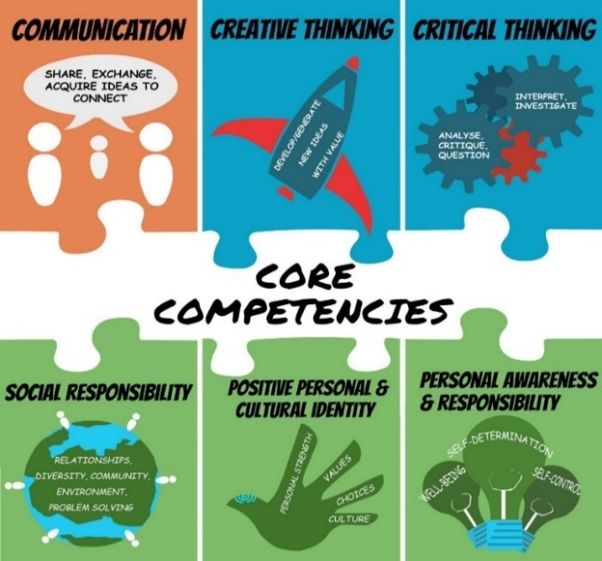

BUILDING GRIT AND RESILIENCE
Grit: continuing to persevere or work through a goal even when we struggle
Resilience: our ability to bounce back after we struggle or fail
INSTRUCTIONS:
- Watch Ted Talk by Dr. Angela Duckworth
https://ted-ielts.com/angela-lee-duckworth-grit-power-passion-perseverance/
- Take the grit-scale and see how you score. (Put link in browser.)
https://angeladuckworth.com/grit-scale/
- Covid 19 has made life difficult and stressful for most families. At school, our extracurricular activities have been cancelled; we can’t spend time with our friends the way we used to; our classes are long and fast paced. Grit and resilience help us cope and adapt to these changes.
- No matter how you scored on the “grit scale”, Dr. Duckworth would say we can all become more “gritty” and resilient with practice. We need to focus on the goals we really want to achieve and keep working hard even when challenges come up. We also need to check in and reflect on our progress from time to time.

- Complete the questions below to help you reflect on Quarter 1 and set goals for the rest of the year.
QUESTIONS:
- During Quarter 1, what went well for you? Explain. Examples: being back in the classroom, having only two courses, seeing my friends, keeping up with homework, playing volleyball, improving math, helping plan a virtual assembly, becoming more fit.
Something that went well in quarter one was that since there was only two classes, I was able to stay on top of homework. I felt that I was struggling less to stay organized. Only having two classes made it much easier to not procrastinate too.

- During Quarter 1, what did you find challenging or disappointing or stressful? Explain.
Something that was challenging during the first quarter was that during the online portions, I was a bit less motivated than I was for in class learning. This made it challenging at times to not procrastinate.

- Think of ONE thing you really want to improve in Quarter 2 (and Q 3&4). Examples: a school subject, a sport, time spent on homework/studying, playing a musical instrument, leadership skills, a language, photography, a relationship, general fitness.
One thing I want to improve during the next few quarters is not procrastinating. I often feel stressed when all my work piles up right before the due dates, so I will work on procrastinating less.

- What are two specific actions that you can start doing every day to get closer to your goal? How long will you spend on this action each day? What part of the day?
- Each day, I will list all the tasks I need to complete within the next few weeks.

- Another thing I will do is prioritize the list that I make, so that I will know what tasks should be done first.

- If you experience challenges, what might you do to work through them? Examples: ask help from a friend or parent; break the task into smaller chunks; “google” how other people may deal with similar problems.
When I am experiencing challenges, I can take short breaks to regain my concentration. I can also look up strategies to keep being motivated.

TO DO for next time… schoolwide check-in: February 2, Quarter 3
- Save artefacts or data along the way –- anything that shows your process (ups and downs) such as work samples or assessments; photos doing the activity; journal comments
- Keep in mind, your goal may be long-term, and may or may not, be reached by Quarter 3 or even by the end of year…it might be ongoing…such as learning a language or becoming more fit
- On May 31, you will complete a year-end self-assessment with reference to two artefacts to show where you are on your journey. This document will be sent home, so parents have insight into your Personal Awareness and Responsibility core competency growth.
- Helpful Hint: Try not to compare yourself to others. We are all at different places. Instead of saying: Why can’t I be like that person who gets 100% or who plays guitar so amazingly? Say: How can I be a better Me today than I was yesterday? What are the steps to get me closer to my best Me?

