GLENEAGLE SCHOOLWIDE CORE COMPETENCY ACTIVITY NOVEMBER 18, 2020
FOCUS: PERSONONAL AWARENESS AND RESPONSIBILITY
Purpose of Activity: To expand Personal Awareness by reflecting on Q1 and setting goals for Q2
Why are we talking about Core Competencies? To help get better at “life.”
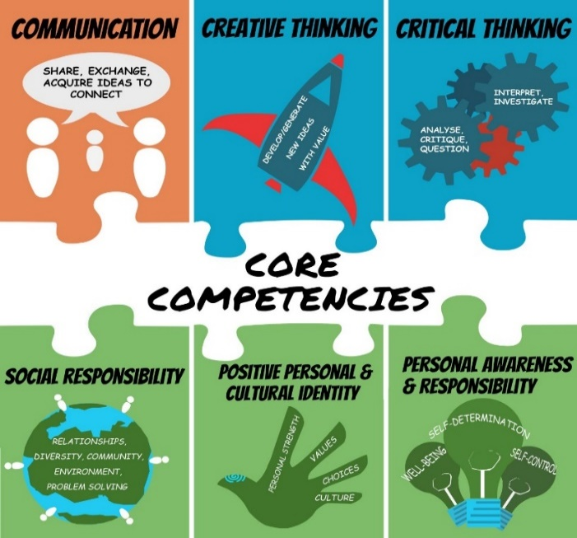

BUILDING GRIT AND RESILIENCE
Grit: continuing to persevere or work through a goal even when we struggle
Resilience: our ability to bounce back after we struggle or fail
INSTRUCTIONS:
- Watch Ted Talk by Dr. Angela Duckworth
https://ted-ielts.com/angela-lee-duckworth-grit-power-passion-perseverance/
- Take the grit-scale and see how you score. (Put link in browser.)
https://angeladuckworth.com/grit-scale/
- Covid 19 has made life difficult and stressful for most families. At school, our extracurricular activities have been cancelled; we can’t spend time with our friends the way we used to; our classes are long and fast paced. Grit and resilience help us cope and adapt to these changes.
- No matter how you scored on the “grit scale”, Dr. Duckworth would say we can all become more “gritty” and resilient with practice. We need to focus on the goals we really want to achieve and keep working hard even when challenges come up. We also need to check in and reflect on our progress from time to time.

- Complete the questions below to help you reflect on Quarter 1 and set goals for the rest of the year.
QUESTIONS:
- During Quarter 1, what went well for you? Explain. Examples: being back in the classroom, having only two courses, seeing my friends, keeping up with homework, playing volleyball, improving math, helping plan a virtual assembly, becoming more fit.
I think what went well for me was having to focus only on two classes instead of more because I struggled a lot with science before, but it gave me more time to focus all my time on it and spend more time in the classroom working on it which I believe made me more successful in it as I would’ve been. Also having a good peer tutor, teacher, and friends my classes made it much easier because I felt comfortable with asking questions.

- During Quarter 1, what did you find challenging or disappointing or stressful? Explain.
Something that is disappointing is that it ends very quickly. Not until the end was I able to get comfortable and make friends in my class and it was very sad to see that it was over. Learning everything in such a short amount of time was also a bit of a challenge, but it did keep me very busy because I spent a lot of my own time working at home.

- Think of ONE thing you really want to improve in Quarter 2 (and Q 3&4). Examples: a school subject, a sport, time spent on homework/studying, playing a musical instrument, leadership skills, a language, photography, a relationship, general fitness.
One thing that I want to improve is my social skills.

- What are two specific actions that you can start doing every day to get closer to your goal? How long will you spend on this action each day? What part of the day?
- Talking to new people in my classes

- Asking more questions

- If you experience challenges, what might you do to work through them? Examples: ask help from a friend or parent; break the task into smaller chunks; “google” how other people may deal with similar problems.
I would just try to keep working at it, but if I’m still struggling, I usually would just google it or ask for help from a teacher or friend.

TO DO for next time… schoolwide check-in: February 2, Quarter 3
- Save artefacts or data along the way –- anything that shows your process (ups and downs) such as work samples or assessments; photos doing the activity; journal comments
- Keep in mind, your goal may be long-term, and may or may not, be reached by Quarter 3 or even by the end of year…it might be ongoing…such as learning a language or becoming more fit
- On May 31, you will complete a year-end self-assessment with reference to two artefacts to show where you are on your journey. This document will be sent home, so parents have insight into your Personal Awareness and Responsibility core competency growth.
- Helpful Hint: Try not to compare yourself to others. We are all at different places. Instead of saying: Why can’t I be like that person who gets 100% or who plays guitar so amazingly? Say: How can I be a better Me today than I was yesterday? What are the steps to get me closer to my best Me?

