**GLENEAGLE SCHOOLWIDE CORE COMPETENCY ACTIVITY NOVEMBER 18, 2020**

**FOCUS: PERSONONAL AWARENESS AND RESPONSIBILITY**

**Purpose of Activity**: To expand **Personal Awareness** by reflecting on Q1 and setting goals for Q2

Why are we talking about Core Competencies? ***To help get better at “life.”***

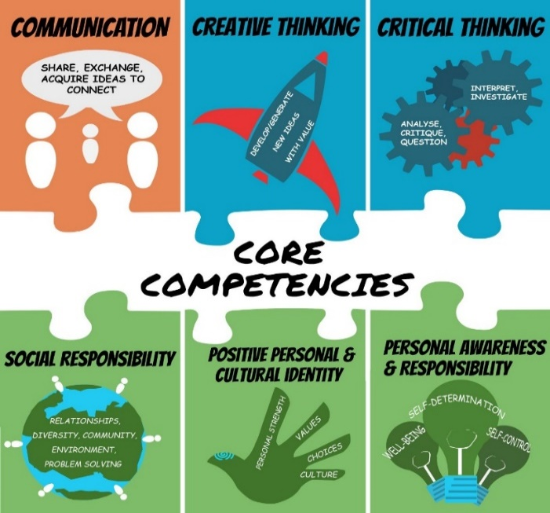



BUILDING GRIT AND RESILIENCE

**Grit**: *continuing to persevere or work through a goal even when we struggle*

**Resilience**: *our ability to bounce back after we struggle or fail*

**INSTRUCTIONS:**

1. **Watch Ted Talk by Dr. Angela Duckworth**

<https://ted-ielts.com/angela-lee-duckworth-grit-power-passion-perseverance/>

1. **Take the grit-scale and see how you score. (Put link in browser.)**

<https://angeladuckworth.com/grit-scale/>

* Covid 19 has made life difficult and stressful for most families. At school, our extracurricular activities have been cancelled; we can’t spend time with our friends the way we used to; our classes are long and fast paced. Grit and resilience help us cope and adapt to these changes.
* No matter how you scored on the “grit scale”, Dr. Duckworth would say we can all become more “gritty” and resilient with practice. We need to focus on the **goals we** **really want to achieve** and keep **working hard** even when **challenges** come up. We also need to check in and reflect on our progress from time to time.

1. **Complete the questions below to help you reflect on Quarter 1 and set goals for the rest of the year.**

**QUESTIONS:**

1. During Quarter 1**, what went well for you?** Explain. **Examples**: being back in the classroom, having only two courses, seeing my friends, keeping up with homework, playing volleyball, improving math, helping plan a virtual assembly, becoming more fit.

|  |
| --- |
| * I was able to maintain a school – life balance. * I was able to find ways to interact with others in a safe way during the time of Covid-19. * I got to see my friends in person for the first time in a while. * I got the opportunity to learn in person. |

1. During Quarter 1, what **did you find challenging** or **disappointing** or **stressful**? Explain.

|  |
| --- |
| * I was disappointed that school was not able to move to full time in school * Adjusting to being back in school for the first time was challenging. * Covid-19 exposures in the community were stressful. |

1. Think of **ONE thing** you really want **to improve** in Quarter 2 (and Q 3&4). **Examples**: a school subject, a sport, time spent on homework/studying, playing a musical instrument, leadership skills, a language, photography, a relationship, general fitness.

|  |
| --- |
| In quarter 2, I want to be able to get outside and exercise more, while managing and completing school assignments. |

1. What are two **specific actions** that you can start doing every day to get closer to your goal? How long will you spend on this action each day? What part of the day?

|  |
| --- |
| 1. Everyday, I want to spend at least an hour outside or exercising. This will be in the afternoon when I get home. 2. To achieve my goal, I can spend at least 3 hours on homework daily. This would also take place in the afternoon and evening as I am in class the rest of the day. |

1. If you experience challenges, what might you do to work through them? Examples: ask help from a friend or parent; break the task into smaller chunks; “google” how other people may deal with similar problems.

|  |
| --- |
| If I face challenges in achieving my goal, I can try to remove distractions that prevent me from spending time outdoors, and spending time on homework. This could be in the form setting time limits on social media, or through playing less videogames. |

**TO DO** for next time… schoolwide check-in: **February 2, Quarter 3**

* Save **artefacts** or **data** along the way –- anything that shows your process (ups and downs) such as work samples or assessments; photos doing the activity; journal comments
* Keep in mind, your goal may be long-term, and may or may not, be reached by Quarter 3 or even by the end of year…it might be ongoing…such as learning a language or becoming more fit
* On May 31, you will **complete a year-end self-assessment with reference to two artefacts** to show where you are on your journey. This document will be sent home, so parents have insight into your Personal Awareness and Responsibility core competency growth.
* Helpful Hint: Try not to compare yourself to others. We are all at different places. Instead of saying: **Why can’t I be like that person who gets 100%** **or who plays guitar so amazingly?** **Say: How can I be a better Me today than I was yesterday? What are the steps to get me closer to my best Me?**

