GLENEAGLE SCHOOLWIDE CORE COMPETENCY ACTIVITY NOVEMBER 18, 2020
FOCUS: PERSONONAL AWARENESS AND RESPONSIBILITY
Purpose of Activity: To expand Personal Awareness by reflecting on Q1 and setting goals for Q2
Why are we talking about Core Competencies? To help get better at “life.”
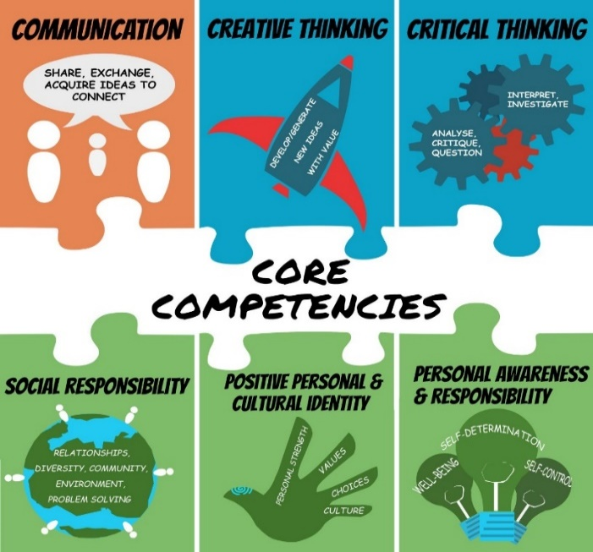

BUILDING GRIT AND RESILIENCE
Grit: continuing to persevere or work through a goal even when we struggle
Resilience: our ability to bounce back after we struggle or fail
INSTRUCTIONS:
- Watch Ted Talk by Dr. Angela Duckworth
https://ted-ielts.com/angela-lee-duckworth-grit-power-passion-perseverance/
- Take the grit-scale and see how you score. (Put link in browser.)
https://angeladuckworth.com/grit-scale/
- Covid 19 has made life difficult and stressful for most families. At school, our extracurricular activities have been cancelled; we can’t spend time with our friends the way we used to; our classes are long and fast paced. Grit and resilience help us cope and adapt to these changes.
- No matter how you scored on the “grit scale”, Dr. Duckworth would say we can all become more “gritty” and resilient with practice. We need to focus on the goals we really want to achieve and keep working hard even when challenges come up. We also need to check in and reflect on our progress from time to time.

- Complete the questions below to help you reflect on Quarter 1 and set goals for the rest of the year.
QUESTIONS:
- During Quarter 1, what went well for you? Explain. Examples: being back in the classroom, having only two courses, seeing my friends, keeping up with homework, playing volleyball, improving math, helping plan a virtual assembly, becoming more fit.
During Quarter 1, I was very successful in building and maintaining my personal relationships and friendships while upholding COVID-19 guidelines. I have reached out to old friends, shared aspects of my life with new ones, and grown closer to the people around me, despite the difficulties we are currently facing. For instance, some of my friends and I connected through a video call platform to watch a movie together.

- During Quarter 1, what did you find challenging or disappointing or stressful? Explain.
During Quarter 1, I was challenged by the changing societal guidelines for the pandemic. This is because these ongoing changes could often be unpredictable and made me feel stressed and uncertain of the future. Moreover, my leadership class faced difficulties in finding methods of adapting to this new situation.

- Think of ONE thing you really want to improve in Quarter 2 (and Q 3&4). Examples: a school subject, a sport, time spent on homework/studying, playing a musical instrument, leadership skills, a language, photography, a relationship, general fitness.
One thing I would really like to improve in Quarter 2 is my management of my stress levels. Over the next quarter, I want to focus on having a better work-life balance. I would also like to discover better ways to feel calm and relaxed. This goal is particularly important to me because I will be taking two very demanding subjects while also preparing for two musical exams.

- What are two specific actions that you can start doing every day to get closer to your goal? How long will you spend on this action each day? What part of the day?
- In order to get closer to my goal, I will take five to ten minutes every morning to write down all of the tasks I need to complete throughout the day.

- In order to get closer to my goal, I will set aside half an hour every evening to pursue activities I am interested in, such as art and piano.

- If you experience challenges, what might you do to work through them? Examples: ask help from a friend or parent; break the task into smaller chunks; “google” how other people may deal with similar problems.
If I experience challenges, I might ask close friends and family for tactics in managing stress. By listening to the insight from others around me, I may be able to mitigate these challenges and help myself grow into a happier, healthier person.

TO DO for next time… schoolwide check-in: February 2, Quarter 3
- Save artefacts or data along the way –- anything that shows your process (ups and downs) such as work samples or assessments; photos doing the activity; journal comments
- Keep in mind, your goal may be long-term, and may or may not, be reached by Quarter 3 or even by the end of year…it might be ongoing…such as learning a language or becoming more fit
- On May 31, you will complete a year-end self-assessment with reference to two artefacts to show where you are on your journey. This document will be sent home, so parents have insight into your Personal Awareness and Responsibility core competency growth.
- Helpful Hint: Try not to compare yourself to others. We are all at different places. Instead of saying: Why can’t I be like that person who gets 100% or who plays guitar so amazingly? Say: How can I be a better Me today than I was yesterday? What are the steps to get me closer to my best Me?

