GLENEAGLE SCHOOLWIDE CORE COMPETENCY ACTIVITY NOVEMBER 18, 2020
FOCUS: PERSONONAL AWARENESS AND RESPONSIBILITY
Purpose of Activity: To expand Personal Awareness by reflecting on Q1 and setting goals for Q2
Why are we talking about Core Competencies? To help get better at “life.”
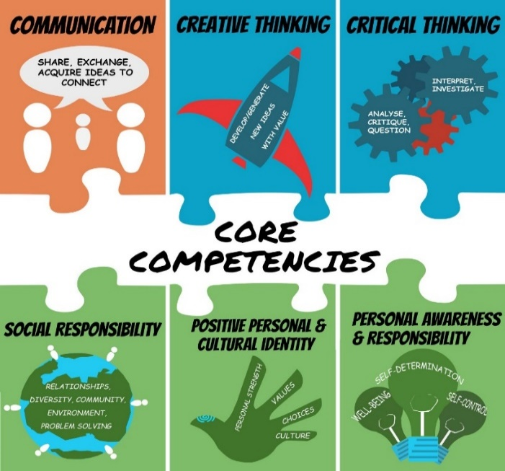

BUILDING GRIT AND RESILIENCE
Grit: continuing to persevere or work through a goal even when we struggle
Resilience: our ability to bounce back after we struggle or fail
INSTRUCTIONS:
- Watch Ted Talk by Dr. Angela Duckworth
https://ted-ielts.com/angela-lee-duckworth-grit-power-passion-perseverance/
- Take the grit-scale and see how you score. (Put link in browser.)
https://angeladuckworth.com/grit-scale/
- Covid 19 has made life difficult and stressful for most families. At school, our extracurricular activities have been cancelled; we can’t spend time with our friends the way we used to; our classes are long and fast paced. Grit and resilience help us cope and adapt to these changes.
- No matter how you scored on the “grit scale”, Dr. Duckworth would say we can all become more “gritty” and resilient with practice. We need to focus on the goals we really want to achieve and keep working hard even when challenges come up. We also need to check in and reflect on our progress from time to time.

- Complete the questions below to help you reflect on Quarter 1 and set goals for the rest of the year.
QUESTIONS:
- During Quarter 1, what went well for you? Explain. Examples: being back in the classroom, having only two courses, seeing my friends, keeping up with homework, playing volleyball, improving math, helping plan a virtual assembly, becoming more fit.
During Quarter 1, some things that went well for me included having the hybrid class that was partially online, using teams for assignments and resources, keeping up good grades, staying in touch with friends, handling my volunteering, my job, and school.

- During Quarter 1, what did you find challenging or disappointing or stressful? Explain.
With the new COVID-19 adaptations, a lot of the structure in English was very different than what I was used to and made the course a little more confusing. For example, altering projects that I had certain expectations for. Along with the COVID-19 exposure later in the term, balancing schoolwork with mental health was difficult.

- Think of ONE thing you really want to improve in Quarter 2 (and Q 3&4). Examples: a school subject, a sport, time spent on homework/studying, playing a musical instrument, leadership skills, a language, photography, a relationship, general fitness.
In Quarter 2 I just want to be able to keep up with the two courses at school. Science and Math are both difficult subjects for me, and since classes are going to be every day and compacted into one quarter, I’m afraid I’m going to fall very behind or be overwhelmed with work. So, I want to be able to complete my work on time and understand the course material.

- What are two specific actions that you can start doing every day to get closer to your goal? How long will you spend on this action each day? What part of the day?
- I think I should spend some time coming up with a proper schedule for my day, so I make sure I work on homework every day and won’t procrastinate. I will spend the first day or so of Quarter 2 coming up with this schedule, so I don’t spend too much time on it before the homework starts rolling in.

- I will set a bedtime for myself, so I don’t get to bed too late. Subjects that I am not very interested in tend to make me very tired and hard to focus, and lack of sleep would only add to that. If I set a proper bedtime for myself, I will be less tired during the day and will be able to focus.

- If you experience challenges, what might you do to work through them? Examples: ask help from a friend or parent; break the task into smaller chunks; “google” how other people may deal with similar problems.
If I am struggling with school subjects, I can ask from help from some of my friends who are really interested in science and who are willing to help me. I can also ask the teacher for help or look up the problems in our Science resources or online.

TO DO for next time… schoolwide check-in: February 2, Quarter 3
- Save artefacts or data along the way –- anything that shows your process (ups and downs) such as work samples or assessments; photos doing the activity; journal comments
- Keep in mind, your goal may be long-term, and may or may not, be reached by Quarter 3 or even by the end of year…it might be ongoing…such as learning a language or becoming more fit
- On May 31, you will complete a year-end self-assessment with reference to two artefacts to show where you are on your journey. This document will be sent home, so parents have insight into your Personal Awareness and Responsibility core competency growth.
- Helpful Hint: Try not to compare yourself to others. We are all at different places. Instead of saying: Why can’t I be like that person who gets 100% or who plays guitar so amazingly? Say: How can I be a better Me today than I was yesterday? What are the steps to get me closer to my best Me?

