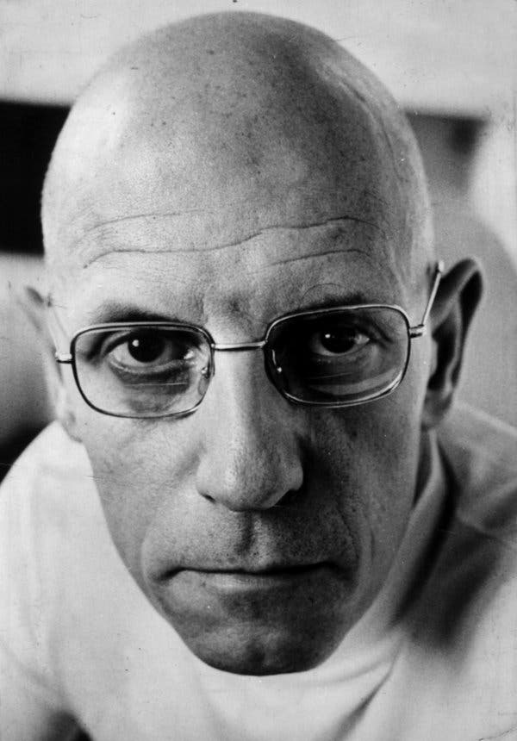  WHO IS MICHEL FOUCAULT?  MICHEL FOUCAULT, born in Poitiers, France, October 15, 1926, was a French philosopher, historian, and social theorist. He is recognized as one of the most influential thinkers of the 20th century. He has made countless substantial contributions to the areas of philosophy,  history, literary criticism, cultural studies, and human sciences. Foucault’s thoughts primarily address the relationship between power and knowledge, and its existence in different disciplines. He critiques societal institutions, such as clinics, asylums, and prisons, and exposes their exploitative exercises of power. His theory of power/knowledge and its applications today will be discussed in this book. | TIMELINE ↓  The Birth of the Clinic  received his doctoral with Madness and Civilization: A History of Insanity in the Age of Reason  The Archaeology of Knowledge: Foucault seeks to describe discourse  Discipline and Punish  History of Sexuality: Volume 1  History of Sexuality: Volume 2 & 3  died of AIDS in Paris on June 25, 1984, at the age of 57  turned to journalism and published articles on the Iranian Revolution  The Order of Things: attracted attention and establishing Foucault as a major figure  studied psychology and philosophy at the École Normale Supérieure d’Ulm  graduated and begin teaching while pursuing a doctoral  moved to Paris  received an aristocratic education in Poitiers, during the German invasion; His experiences under the German regime is suspected to be behind his theory of power/knowledge.  born into a bourgeois family of surgeons and medicine; this background later became the root of his work revolving around medical discourse.
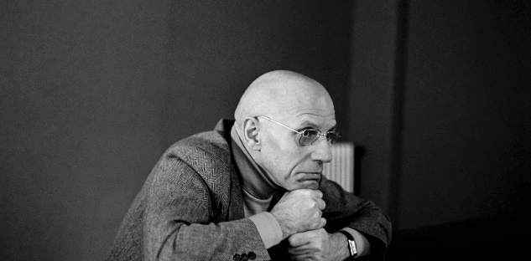  definitions:  - power is not a thing but a relation  - power is not simply repressive but it is productive  - power is not simply a property of the State. Power is not exclusively localized in government and the State. Rather, it is exercised throughout the social body.  - power operates in all social relations, and it’s present at every level of the social body.  - the exercise of power is strategic  - “Power is everywhere”, and “comes from everywhere”  Furthermore, he clarifies that power cannot be completely described by any definition  Foucault’s definitions of power aren’t homogeneous; he refines his definitions over time.  POWER AND HOW IT WORKS | POWER RELATIONS  Foucault believes that power is only active in a power relations.  A power relation consists of two forces that attempt to bring the other under its influence and control. The stronger force will shape the weaker force and direct its conduct towards the weaker force. Foucault suggests that if there’s a power relation, there are possibilities of resistance, no matter how oppressive the system.  pastoral power:  individualizing power that is exercised with the individualizing knowledge of conscience of the people and the ability to direct the conscience  disciplinary power:  Power that regulates the behavior of individuals in society through the organization of space, time, activity, and behavior  sovereign power:  A pyramid-like structure that aims to dominate. The person/group holding power is at the top of the pyramid, the people who are suffering oppression are at the bottom of the pyramid, and the enforcers of the sovereigns’ orders are at the middle of the pyramid.  TYPES OF POWER
“Savoir” and “Connaissance”  These two French words both translate to knowledge but have different meanings to Foucault. These terms are especially important in the discussion about the power/knowledge theory, or as it’s known as in French, “pouvoir/savoir”.  Savoir: a process where subjects are created and turned into objects for knowledge.  Example: “A criminal” is created to become an object of knowledge that can be studied through science.  Connaissance: knowledge about these objects  Example: the studies of criminals and the knowledge earned from the studies  Similar to Foucault’s relationship with power, his definitions of knowledge are sometimes conflicting. In this chapter, we’ll discuss four terms, three of which are specific type of knowledge.  Historical Knowledge and Discourse-stemmed knowledge  In “The Order of Things’ and “The Archaeology of Knowledge”, Foucault focuses on knowledge from two perspectives, historical knowledge, and discourse-stemmed knowledge. Both types of knowledge are influenced by power. This is the power/knowledge relationship. We’ll examine this theory later on.  Historical Knowledge: knowledge that was generated in the past and historically contingent (as there’s no absolute knowledge).  Discourse-stemmed knowledge: knowledge gained from discussions and simulations of historical knowledge.  KNOWLEDGE AND HOW DOES IT WORK | 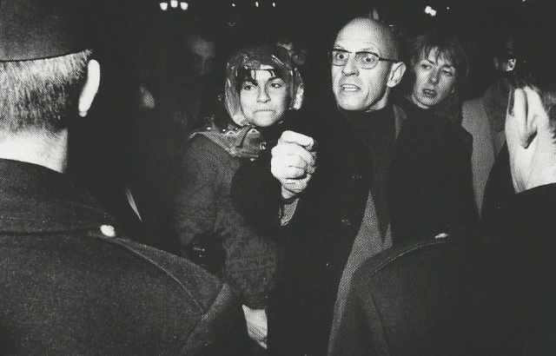
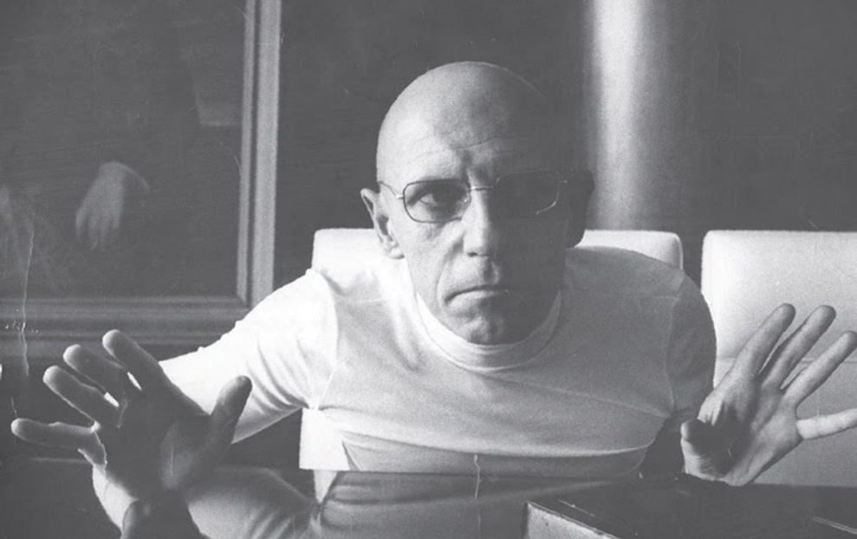  Foucault believes that knowledge and power are intimately intertwined. He appreciates this complex dynamic, coining it “pouvoir/savoir”, power/knowledge, to demonstrate that one is not separate from the other. In this theory, every exercise of power depends on the knowledge that supports an action and the knowledge that a particular action will advance the existing power. In short, knowledge is power and power defines knowledge.  “in knowing we control and in controlling we know”  WHAT IS POWER/ KNOWLEDGE THEORY | An example of the power/knowledge theory is the Panopticon theory, the inspiration of Foucault’s power/knowledge theory. Foucault expanded Jeremy Bentham’s disciplinary concept of prison architecture, where a central observation tower is placed with a circle of prison cells to observe the prisoners without them knowing, into a metaphor for social control. The mechanisms of this concept are based on knowledge from disciplinary sciences that aim to make all bad deeds, as defined by power, visible and correctable. Foucault believes that, though Panopticon is only a prison structure, it will result in docile people who fit the discipline of the current power in control when applied to the mass public. People will be controlled by efforts to become a scientifically determined “norm” that excuses all bad deeds. Panopticon is an exercise of the power/knowledge theory because knowledge of discipline and punishment, to some extent, becomes the power that disciplines the people and establishes the immorality of certain actions, redefining knowledge to support certain ideals.
In “The History of Sexuality”, Foucault examines the power/knowledge theory concerning sexuality in the 19th century, where it wasn’t just simply repressed, but encouraged in scientific literature and clinical settings. However, in the 20th century, conceptions of sexuality became the results of specific cultural conventions and mechanisms of power. Foucault believes these constraints to be from the conversations of sexuality in the 19th century. He explains that the knowledge gained from the 19th century was applied by the powers of the 20th century to oppress and shape the perceptions of sexuality.  In “Discipline and Punish”, Foucault observes the power/knowledge theory in France’s shift from a monarchy to democracy. He believes that the transition is oversimplified into the achievement of freedom as power still controls people through their minds. He discusses how, with knowledge and studies of discipline, the French government has reshaped punishment into more humane practices that serve to discipline. These practices are seen in prison, schools, factories, and asylums; they produce obedient citizens who comply with social norms because their behaviors are constantly sculpted and forced to internalize the dominant beliefs, knowledge, and values of society.  Foucault’s work | Foucault’s power/knowledge theory is regarded as a productive theory that explains the mechanisms of power and knowledge, and its interactions with the world. However, through my analysis, the power/knowledge theory will also be portrayed as constraining as it cannot explain every interaction of the world. But, to what extent is the Power/Knowledge theory still relevant today?  TO WHAT EXTENT IS MICHEL FOUCAULT'S POWER/ KNOWLEDGE THEORY RELEVANT TODAY?
Language is knowledge; it will always spark discourse and conversation that will ultimately end in knowledge. Without literature and words, our options will be constrained.  In “1984”, by George Orwell, Big Brother invents Newspeak, a language that constantly attempts to reduce the number of words in the world. Big Brother’s power shapes language, which limits the knowledge available.  Today, when you go to a market to buy organic food and the market doesn’t differentiate between organic and regular produces, your options become limited as the words available are limited. Therefore, the lack of conversation in the type of produces in a market translates to your lack of power. The market’s power controls the language in this market and ultimately, limits the options of produces and your power.  The power/knowledge theory is relevant from a linguistics perspective as the language is controlled by power. However, as demonstrated in the modern example above, not all powers are from knowledge, power can also stem from ignorance.  When words disappear  When power controls knowledge  How will the World speak?  LINGUISTICS | The power/knowledge dynamic is apparent in the education system of today, where knowledge gives teachers and professors the power to shape the knowledge students receive. Therefore, from the perspective of education, the power/knowledge theory is relevant.  Though education isn’t aimed to marginalize children, sometimes, it does occur.  The knowledge behind this power is the behavioral and psychological knowledge of students. Teachers use this knowledge to exercise power over their students with the threat of academic failure and a hopeless future.  The curriculum is built by the education departments and educated professors, and implemented by teachers, who have been educated with the necessary knowledge for them to have power.  Teachers and professors now define and shape knowledge.  Education is dependant on the curriculum  EDUCATION
Law:  The knowledge is needed for one to assume an effective position of power; in this case, the position of power is governmental. Laws are made, by these powers, with the knowledge that they will better the society by building order and marginalizing criminals. Power determines the acceptability of so-called “crimes” and sets limitations for further knowledge and behavior to be based upon. These limitations are not always obeyed.  The power/knowledge theory is intertwined with the law. It explains the mechanisms behind the creation of laws.  Of a democracy  Prisons:  Disciplinary research results in developed knowledge of crime and effective punishment. This knowledge is utilized to control and monitor criminals; here, knowledge is transformed into power. This power then continues to act according to research, determining the boundaries of further research.  Though times have shifted and the prison system has changed, the power relation still exists. In prisons today, the power/knowledge theory is still relevant.  CRIMINAL SYSTEM | 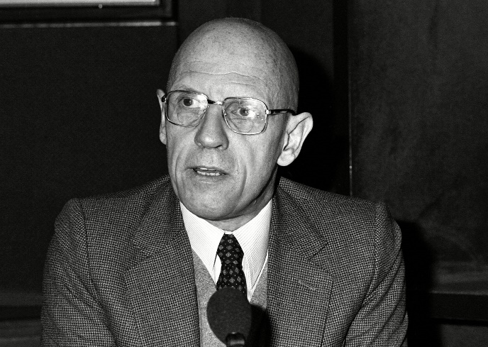  In a doctor-patient relationship, doctors have more medical knowledge than patients. This knowledge gives doctors a sense of power over their patients. Though doctors don’t generally exercise this power to marginalize their patients and control the knowledge the patients receive, there are moments where that occurs. Rare incidents of abuse can happen, and sometimes, doctors prescribe placebo pills and influence their patients to believe these to be real medicine.  Though a power/knowledge relation exists, power in medicine isn’t generally exercised for control. However, in medical education, this relationship, as proven in previous chapters, exists. Overall, in medicine, there’s an underlying theme of power and knowledge, but it’s not generally exercised.  MEDCINE
Economy  Individual:  Since the existence of money, more knowledge generally correlates with more money. In capitalistic societies today, money equals power. Therefore, like a mathematical equation,  if A (knowledge) = B (money)  and  B (money) = C (power),  A (knowledge) = C (power).  Money is then able to determine the education and knowledge one receives.  Collective:  The equation above shows that the economic growth of a society is determined by the average of its education level. The economy and economic influence are key factors to the power of a society and the knowledge of a society.  On the surface, the economy supports the power/knowledge theory. However, if we dig deeper, one realizes that the power/knowledge theory creates an ongoing cycle of poverty. Therefore, Foucault’s theory in economics is constraining as it denies the possibilities of motivations that isn’t power. | 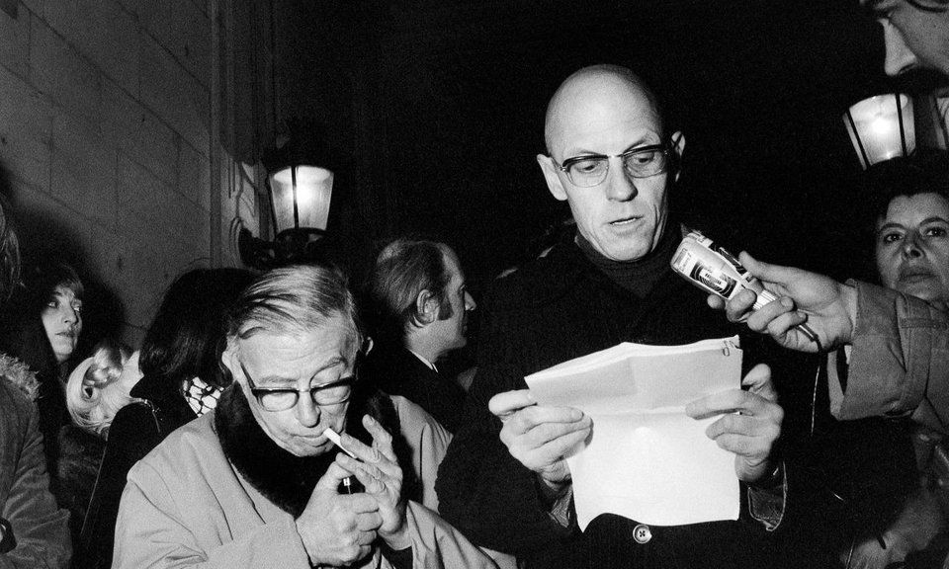  The more research and knowledge of the environment means that humans have more power over it. Through knowledge, we learn how to save the environment and how to destroy it. Previously, this power was focused on earning a profit, but now, it’s directed to save the environment. Moreover, this power over the environment determines the future.  But, it doesn’t define knowledge. Michel Foucault’s analysis of power and knowledge’s relation is ineffective here. There are way too many variables in the relationship between the environment, power, and knowledge to be quantified into the power/knowledge theory. Again, Foucault’s theory doesn’t account for the variables other than power and knowledge, limiting the theory.  Environment
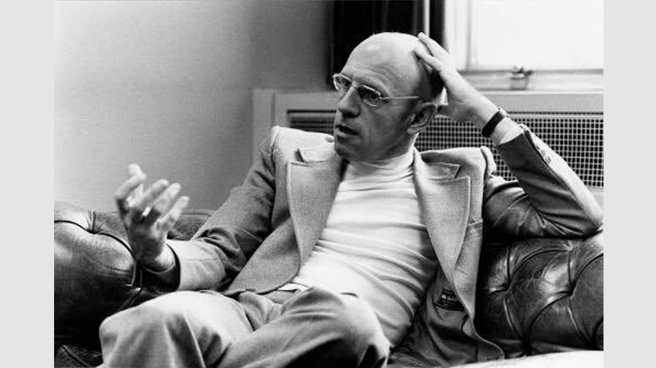  With the rise of big data, technology becomes a source of power. This is how technology gains power:  - When a user consent to the collection of data, technology gains the user’s data and knowledge  - They interpret this data and shape the knowledge receivable by users online through algorisms  - This knowledge gives technology power over its users  The modern exercise of the power/knowledge theory is best presented by technology. This relationship exists and functions. Though this power isn’t a type of power that Foucault foresaw, the theory is adaptable to the modernization of technology. The relationship between power and knowledge is relevant to technology.  Technology | The existence of the power/knowledge theory in governments can be observed through two basic government structures, democracy and dictatorship. We’ll examine how power and knowledge function in democracies and dictatorships.  Dictatorship is one of the subjects of Foucault’s criticism. He used the power/knowledge theory to explain how these governments keep in power. Dictators recognize that knowledge is power and uses censorships to oppress their citizens. Because of these censorships, dictators have more knowledge than their citizens; this is their power over their citizens. They then control the amount of knowledge their citizens are able to receive; this is still occurring today. Power and knowledge’s relationship is clearly illustrated through a modern dictatorship.  In a democracy, knowledge is fundamental. Knowledge makes citizens informed, giving them power. However, in a power relation with aristocrats, citizens are, to some extent, controlled. Aristocrats have more knowledge than the general public as they are already in positions of power. Therefore, they’re able to mold the knowledge perceived by the public. The power/knowledge theory is a relevant theory that explains the inner workings of a democratic government.  Governments
Throughout our exploration, I believe that Michel’s Foucault’s theory of power/knowledge is proven to be relevant today. However, we need to recognize that this theory is constraining, as evident in Economy and Environment. Foucault’s analysis of the relationship between power and knowledge is limited because he doesn’t acknowledge other variables in society. At the same time, Foucault’s theory allows us to better understand how power and knowledge interact with each other and the world.  NOW, TO WHAT EXTENT IS MICHEL FOUCAULT'S POWER/ KNOWLEDGE THEORY RELEVANT TODAY? | The following, according to an order published at the end of the seventeenth century, were the measures to be taken when the plague appeared in a town. Now, let’s make art.  Bentham’s Panopticon is the architectural ﬁgure of this composition. We know the principle on which it was based: at the periphery, an annular building; at the centre, a tower; this tower is pierced with wide windows that open onto the inner side of the ring; the peripheric building is divided into cells, each of which extends the whole width of the building; they have two windows, one on the inside, corresponding to the windows of the tower; the other, on the outside, allows the light to cross the cell from one end to the other. All that is needed, then, is to place a supervisor in a central tower and to shut up in each cell a madman, a patient, a condemned man, a worker or a schoolboy. By the effect of backlighting, one can observe from the tower, standing out precisely against the light, the small captive shadows in the cells of the periphery. They are like so many cages, so many small theatres, in which each actor is alone, perfectly individualized and constantly visible. The panoptic mechanism arranges spatial unities that make it possible to see constantly and to recognize immediately. In short, it reverses the principle of the dungeon; or rather of its three functions — to enclose, to deprive of light and to hide — it preserves only the ﬁrst and eliminates the other two. Full lighting and the eye of a supervisor capture better than darkness, which ultimately protected. Visibility is a trap.

