What role do salmon play in local First Nations along our coast and inland?
- Introduction
- Topic Question
What role do salmon play in local First Nations along our coast and inland?

- Introductory Statements
- Salmon have a significant role to First Nations’ economy
- Salmon have an important role to First Nations culture
- Salmon are important to First Nations spiritually

- Salmon play an important role in First Nations’ economy.

- First Nations have a long history of harvesting salmon

- Historically, many First Nations groups wealthy due to a booming trade economy based on salmon

- A variety of advanced fishing gear allows First Nation to target different species of salmon at the same site and monitor salmon populations

- In the Fraser River Canyon, fishers would gaff or dip-net for fish

- In shallow or slow-moving streams, weirs were used to lead the salmon into traps or fishers with other equipment

- These indigenous fishing techniques were efficient, and the harvesting was controlled and regulated

- Indigenous fishers found economic opportunity during the 19th century in industrial fishing

- The money earned from fishing paid for supplies in the winter

- Although some First Nations communities oppose the idea of farm-raised salmon, many First Nations communities support them, as it provides a significant source of income

- Farm-raised salmon is BC’s largest agricultural export, contributing to over 1.4 billion dollars. A portion of this money goes directly to First Nation communities

- Salmon have an important role in the culture of the First Nations.

- The Legend of the Salmon People are stories told by many First Nations
- These tales helped to shape traditions and lifestyle of First Nations people
- The stories about the Salmon People have changed over time to pass on lessons learned through history
- The stories tell the First Nations people to maintain the fishing traditions of the First Nations and to not overfish for commercial purposes
- The stories warn First Nations to not become too greedy and to respect nature and the salmon
- The stories preserve the First Nations’ culture and are told by the First Nations to teach future generations to respect the salmon people
- The First Nations people tell people to appreciate living in harmony with the salmon people

- Salmon are a symbol of the First Nations, representing regeneration and perseverance

- Many First Nations stories and artwork involve salmon, showing the First Nation’s connection to nature and struggles to maintaining their cultural identity
- See Diagram A in Appendix - Image of a First Nation traditional symbol of salmon
- See Diagram B in Appendix – Image of an Aboriginal salmon pillar carving

- Salmon are important to First Nations’ spiritual identity.

- First Nations believe in a spiritual world, and that it is connected to the physical world.

- First Nations believe that salmon give people the gift of life

- First Nations believe animals have spirits, and that they enter the human world to provide to food and other resources to humans. Once their body is used, the animals return to their own world and can return to the human world again.

- First Nations respect the animals to ensure that they will return

- People would throw the entire fish skeleton into the water after the salmon was eaten believing its spirit would rise again

- First Nations legends tell tales of salmon granting knowledge and powers to shamans

- To First Nations, salmon are often associated with twins and carved in pairs

- Conclusion

- First Nations along our coast and inland are deeply connected to salmon in many ways. They are an essential component to their economy, culture, and spiritual identity.
- The First Nations’ deep relationship with salmon allow them to connect with nature and to maintain the ecosystem.

Appendix
Diagram A:
Retrieved from: https://artinas.com/legend/salmon/.

Diagram B:
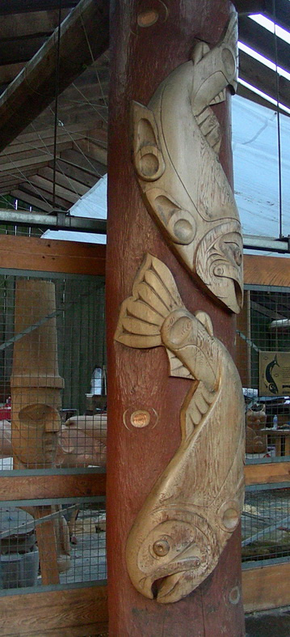
Retrieved from : https://cyclewriteblog.wordpress.com/2015/05/07/salmon-art-leaps-into-pacific-west-coast-imagination/

Works Cited
Aboriginal Fisheries in British Columbia. Indigenousfoundations.arts.ubc.ca. (2020). Retrieved 20 May 2020, from https://indigenousfoundations.arts.ubc.ca/aboriginal_fisheries_in_british_columbia/.
https://indigenousfoundations.arts.ubc.ca/aboriginal_fisheries_in_british_columbia/

Economic Benefit to Coastal Communities | Positive Aquaculture Awareness, salmon fish farming facts. Farmfreshsalmon.org. (2020). Retrieved 20 May 2020, from https://farmfreshsalmon.org/economic-benefits-salmon-aquaculture.
https://farmfreshsalmon.org/economic-benefits-salmon-aquaculture

Living Legends: The Teachings of the Salmon | Indigenous Tourism BC. Indigenous Tourism BC. (2020). Retrieved 20 May 2020, from https://www.indigenousbc.com/stories/the-teachings-of-the-salmon.
https://www.indigenousbc.com/stories/the-teachings-of-the-salmon

Native Legends: The Salmon. Artinas Jewellery. (2020). Retrieved 28 May 2020, from https://artinas.com/legend/salmon/.
https://artinas.com/legend/salmon/.

Return to the water: First Nations relations with salmon. Www2.laiwanette.net. (2020). Retrieved 20 May 2020, from http://www2.laiwanette.net/fountain/return-to-the-water-first-nations-relations-with-salmon/.
http://www2.laiwanette.net/fountain/return-to-the-water-first-nations-relations-with-salmon/

Salmon Art Leaps Into Pacific West Coast Imagination. Cycle Write Blog. (2020). Retrieved 28 May 2020, from https://cyclewriteblog.wordpress.com/2015/05/07/salmon-art-leaps-into-pacific-west-coast-imagination/.
https://cyclewriteblog.wordpress.com/2015/05/07/salmon-art-leaps-into-pacific-west-coast-imagination/

Salmon Culture | Pacific Northwest tribes, Columbia River salmon. CRITFC. (2020). Retrieved 28 May 2020, from https://www.critfc.org/salmon-culture/tribal-salmon-culture/.
https://www.critfc.org/salmon-culture/tribal-salmon-culture/

The Salmon Symbol. Spirits of the West Coast Art Gallery Inc. (2020). Retrieved 20 May 2020, from https://spiritsofthewestcoast.com/collections/the-salmon-symbol.
https://spiritsofthewestcoast.com/collections/the-salmon-symbol

